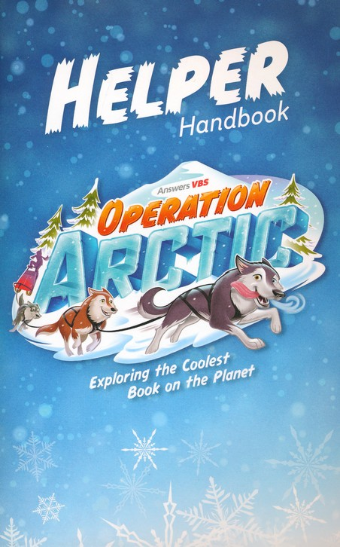
Ecumenical Vacation Bible School 2017
When: Wed. August 23 - Friday Aug 25

9:00 am to 11:45 am

Where: St. Paul’s at 62 Clyde St. Almonte

Who: Children 4 – 10 years of age

Why: Join us on this Arctic Adventure to learn more about God and life in the north through stories, music, snacks, crafts, science and games.

Registration: Please email Judy Best at mjbest@rogers.com
There is no cost for this VBS. Any donations will go towards one of our charities.

